MASTER PROJECT : PROPOSAL & PROJECT PLAN

P r e p a r e d B y :

G r o u p 3

H o s s ai n

E v e n

T o n gy e D h r u v al

# We chose Even’s and Hossain’s work as the best design for our project. The comparison between the two will be given below:

T H E R E D C O M P A N Y

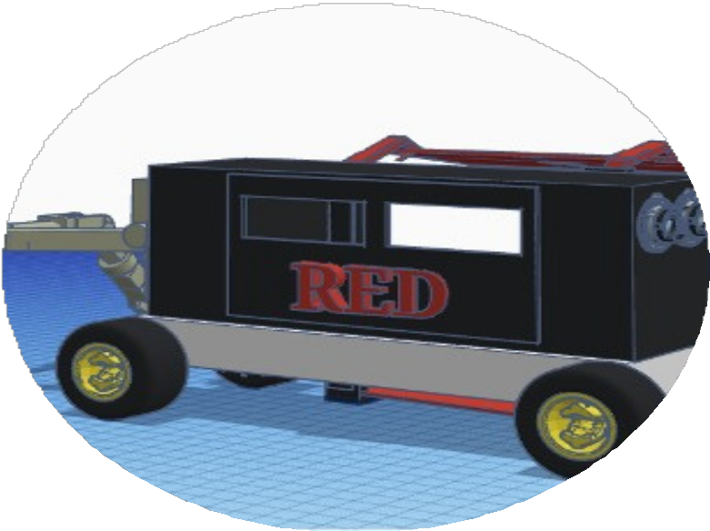

PROPOSAL

D E S I G N

-EVEN-

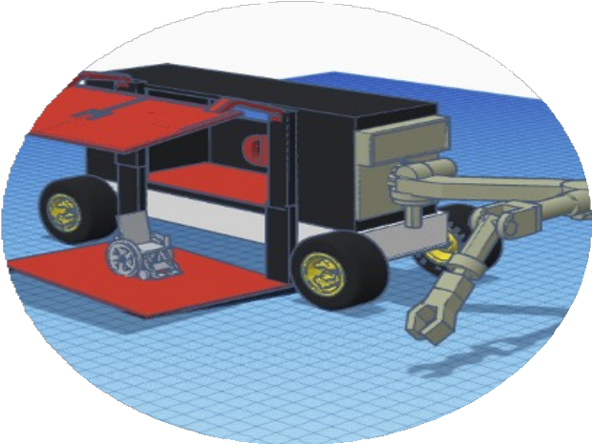

ABOUT DESIGN

**The Project**

The color red symbolizes problems and emergencies. We are here to solve red with RED.

Our mission is to serve the elderly and disabled. Our problem is how to move passengers to the destination quickly and safely.

This project is made by Even and has the following ratings :

**Speed : 6**

**Power : 7**

**Size : 9**

**Cost :8**

**FEBRUARY 2024**

**THE RED**

**COMPANY**

Project Proposal

PROJECT PROPOSAL

**-Hossain-**

**GET TO KNOW RED**

The color red symbolizes problems and emergencies. We are here to solve red with RED.

Our final users are the elderly and disabled. Our problem is how to move passengers to the destination quickly and safely.

This project is made by Hossain and has the following ratings :

**Speed : 6**

**Power : 6**

**Size : 5**

**Cost : 4**

**Features of the Designs:**

**Design 1: Innovative Wheelchair Access: A Forklift-Inspired Solution. (Even’s Design)**

* Utilizes a forklift-like mechanism to lift the wheelchair into the vehicle, providing shade and staying out of the way during the process.
* Uses cameras for autonomous operation, ensuring safe and precise movements.
* Employs a magnetic force on the forklift surface to stabilize the wheelchair.
* Includes seatbelts, hooks to keep the wheelchair in place, and a suitable suspension for stability.
* Features emergency caller buttons and a health monitor to call emergency services if needed.

**Design 2: Efficient and Safe: Redefining Wheelchair Accessibility. (Hossain’s Design)**

* Hossain's design focuses on the materials used.
* Maximizes privacy and safety by being fully automatic with no need for a driver.
* Includes tinted windshields and glasses, along with cameras and sensors for safety.
* Features a 911 emergency button, seatbelts, robotic arms to hold the wheelchair securely, and good suspension to minimize movement inside the car.

Why we Chose Even’s Work ?

**A Safer, More Functional Approach to Wheelchair Accessible Vehicles**

**Lack of Ramp and Two Lift Options:**

Even's design stands out because it does not require a ramp for wheelchair access and offers two ways to lift the wheelchair, making it more versatile and user-friendly.

**Integrated Design Concept:**

Even's design elements work well together and complement each other, indicating a well-thought-out and cohesive design approach.

**Use of Magnetics for Stabilization:**

The use of magnetics on the lift in Even's design is praised for its effectiveness in stabilizing the wheelchair during the loading process, enhancing safety.

**Safety Concerns with Hossain’s Design:**

Hossain’s design is criticized for not having a proper way to lift passengers, which could be unsafe. Additionally, the presence of open spaces where the rider could potentially be ejected raises safety concerns.

**Simplicity vs. Functionality:**

While Hossain’s design aims to reduce costs by simplifying the design, it is noted that this simplicity may lead to the elimination of necessary functionalities, ultimately increasing costs in the long run.

**Safety Hazards in Hossain’s Design:**

Hossain’s design includes a front glass panel that could be dangerous in emergency stops, potentially causing the rider to be flung into it and injured.

**Overall Benefits of Even's Design:**

Even's design is seen as offering more features that benefit both clients and the company, emphasizing safety and functionality as key priorities.

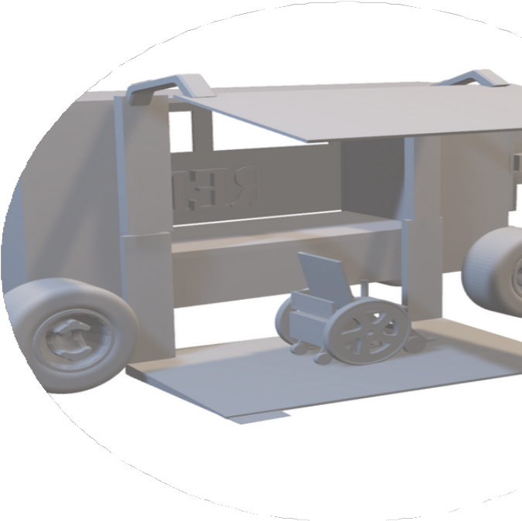

Gantt Chart

